Data Using Python Analysis Final Project
Neresha Miller (Group Leader)
Collins Onokala (Group Member)
CTEC 298
Professor Bemley

Introduction
For the CTEC 298 final project, our group applied all the skills learned during this whole class period. Such as Python, visualizations, data cleaning, and tools that are used in data science. During this final each group member shared process involved cleaning the dataset, organize variables, and filter out unnecessary information so we could focus only on what was relevant to our research questions. This paper documents our collectve process and highligts the significance of the produced visualizations.
Our projects was important because it showed how data can be used to answer real questions, reveal trends, and support evidence-based conclusions. By creating charts and visualizations, we learned how to communicate patterns in a way that is easy to understand and visually clear. Working through the steps from raw data to final visualizations helped us see why data literacy is a valuable skill in almost every field today. Being able to clean, analyze, and present data not only strengthens decision-making but also helps tell a more accurate story about the issues we study.
Summaries of CTEC 128 papers
A Summary 1 – Neresha Miller (Group Leader)
My CTEC 128 project examined how occupation, education, and gender intersect among African American residents ages 18–62 in Maryland using ACS PUMS microdata. The goal was to identify the most common occupations held within this demographic, explore how occupational patterns differ between men and women, and analyze how educational attainment varies across different job categories. To answer these research questions, the PUMS dataset was cleaned, filtered, and prepared by selecting only Maryland respondents within the specified age range. Variables such as occupation (OCCP), education level (SCHL), gender (SEX), employment status (ESR), and personal weights (PWGTP) were used to create accurate and representative findings.
The project required data visualization tools and spreadsheet software to make the results clear and easy to interpret. Excel or statistical tools were used to organize the data, remove missing or irrelevant values, recode variables, and calculate totals and percentages. Charts such as bar graphs and stacked bars illustrated the top occupations among African Americans, gender differences in job distribution, and the relationship between education and occupation. These visualizations helped reveal workforce trends, disparities, and opportunities for improvement in Maryland’s labor market, providing meaningful insights into how race, gender, and education shape economic outcomes for working-age adults.
B. Summary 2 – Collins Onokala
My dataset was collected from the NICS firearm background check records for September 2023. Information was organized by state, and categories such as permits, handguns, long guns, other purchases, and multiple purchases were included. Totals were calculated so that overall activity could be compared more easily across states. The first step involved preparing the dataset for analysis. Column names were standardized, and totals were verified to ensure accuracy. Once the data was ready, six different plots were created to highlight different aspects of the information. Each plot was selected to show a unique perspective, and together they provided a comprehensive view of firearm transactions during the month.

Description of CTEC Material
A. Description – Group Leader Neresha Miller
For my CTEC 298 final project I used the dataset that I found in CTEC 128 project. The data is from the American Community Survey (ACS) Public Use Microdata Sample (PUMS) for Maryland. The ages from the data is from 18-62 because 18 in America is legal and 62 is where I decided to stop for retirement. PUMS data helps uncover who works where, in what jobs, and with what education so we can identify disparities that affect opportunities and outcomes.It shows whether African American workers are concentrated in lower-paying or less secure occupations.It highlights gender gaps, such as women being underrepresented in high-paying technical or leadership roles.This data provides evidence of occupational segregation and barriers that might not be visible from general statistics. Education is one of the biggest predictors of job type and income.PUMS data lets you see how education levels translate into occupations and wages.You can identify whether degrees are paying off equally for everyone or if certain groups face barriers even with higher education.It helps policymakers and schools understand what kinds of education and training programs Maryland needs to prepare residents for better jobs. By looking at occupation by gender and race, you can explore how social and economic systems shape employment patterns.It helps reveal whether men and women have equal access to different types of jobs and equal pay.It shows how race and gender intersect for instance, how African American women’s job patterns differ from African American men’s or White women’s. Understanding these dynamics is key to promoting equity and fair representation in Maryland’s workforce. State and local governments use this data to guide economic, educational, and workforce policies.It identifies which industries or occupations could benefit from targeted job training or investment.It helps design programs that close racial and gender gaps in employment and income.Organizations like Maryland’s Department of Labor or community colleges use these findings to plan career pathways and technical education programs.
B. Description – Collins Onokala
The material submitted for CTEC 298 was focused on applying data analysis and visualization skills to a real‑world dataset. The firearm background check records from September 2023 were selected because they provided multiple categories of numeric data across all U.S. states. The dataset was organized into columns such as permits, handguns, long guns, other purchases, multiple purchases, and totals, which allowed for both categorical and geographic comparisons.
The project required six different plots to be created, each demonstrating a different visualization technique. A bar plot was used to highlight the states with the highest totals, while a stack plot was applied to show how categories contributed to overall activity in each state. A scatter plot was included to compare handgun and long gun transactions, and a pie chart was created to simplify the nationwide distribution between those two categories. A histogram was used to display how states were spread out by total transaction counts, and finally, a multiplot dashboard was assembled to combine several perspectives into one view.
Plot/Visulaization Deliverables
A. Description – Group Leader Neresha Miller
Bar Plot – Gender Distribution
The bar plot displays the number of individuals in the dataset by gender. This visualization makes it easy to compare how many males and females are included within the filtered age range of 18–62. Bar charts are especially helpful for showing differences between categories, and here it clearly reveals whether one gender is more represented in the dataset than the other. This helps provide context for later comparisons involving occupations or income, since knowing the gender distribution ensures that findings are not skewed by an uneven sample.
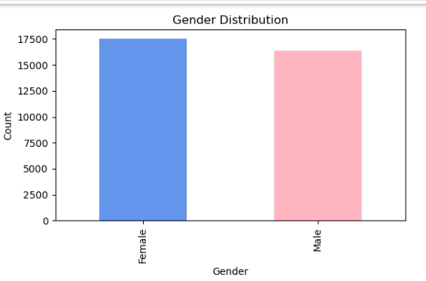
Pie Chart – Black Race Indicator
The pie chart shows the proportion of individuals identified under the "RACBLK" indicator, which typically represents whether a person identifies as Black or African American. The chart gives a quick and intuitive visual breakdown of how many respondents fall into each group, using percentages to show their share of the whole. Pie charts are useful when you want to present how a single variable is divided into categories, and this visualization helps establish the demographic composition of the dataset before deeper analysis.
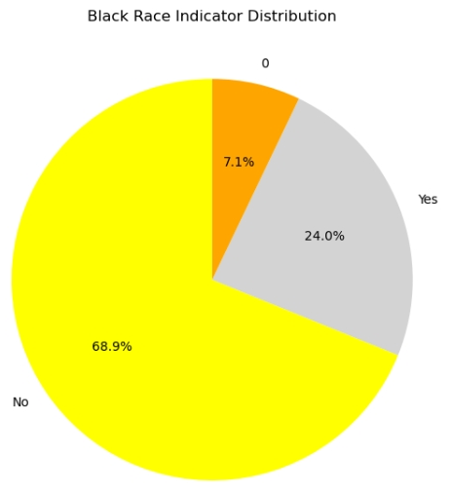
Histogram – Age Distribution
The histogram displays how ages (18–62) are distributed across the dataset. Instead of showing individual points, the histogram groups ages into bins to reveal patterns such as clusters, peaks, or gaps. This helps you see whether the dataset contains more younger adults, middle-aged individuals, or older adults closer to the upper limit. Understanding this age distribution is important because age can influence factors like employment type, wage levels, and educational attainment.
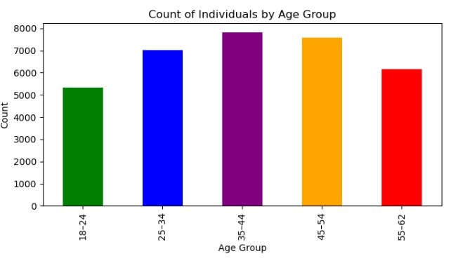
Scatter Plot – Age vs. Income
The scatter plot shows the relationship between age and reported income (WAGP). Each point represents one person, with age on the x-axis and income on the y-axis. Scatter plots are ideal for detecting patterns, correlations, or outliers. This visualization helps you see whether income tends to increase with age, whether younger individuals cluster at lower wage levels, or whether there is no clear relationship at all. It provides insight into how earnings differ across the working-age population.
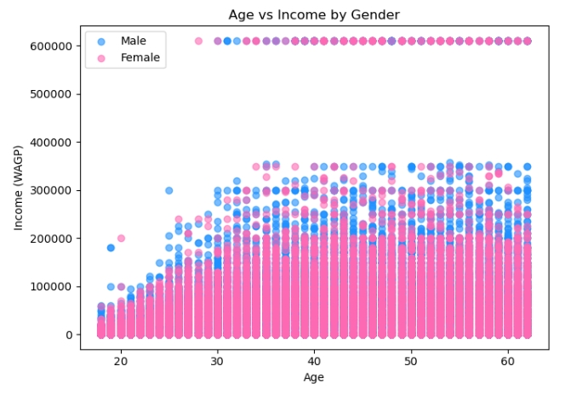
Stack Plot – Age by Gender
The stack plot shows the distribution of age counts separated by gender. Each layer in the stack represents a gender category, stacked on top of each other to show the total number of people at each age while keeping gender differences visible. Stack plots are useful for showing how subgroups contribute to the whole. This helps illustrate whether males or females dominate certain ages within the dataset, and how the overall population shape differs across genders.
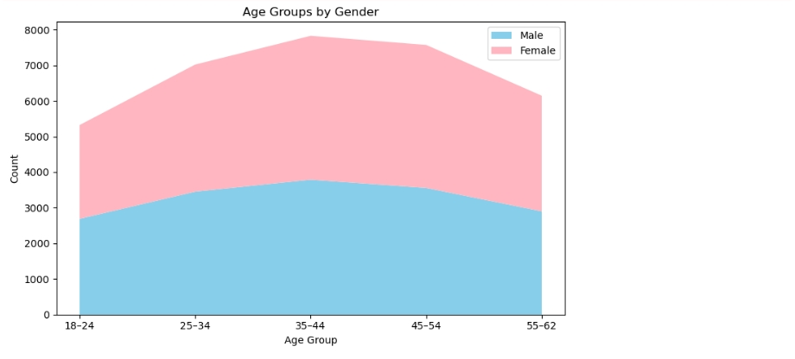
Multiplot – Income & Age Side-by-Side
The multiplot contains two histograms: one showing income distribution and the other showing age distribution. Displaying them side-by-side allows you to compare two different variables without switching charts. The income histogram shows how wages are spread across the dataset, which can reveal common wage levels, inequality, or skewness. Meanwhile, the age histogram (repeated from above) provides demographic context. Together, these plots help connect demographic patterns with economic outcomes, preparing the foundation for deeper occupational analysis.
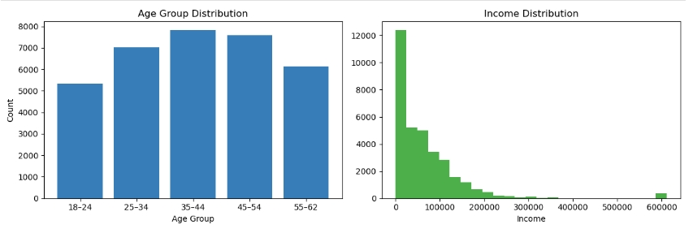
B. Descripition – Collins Onokala

Bar chart – Top 10 sates by totals
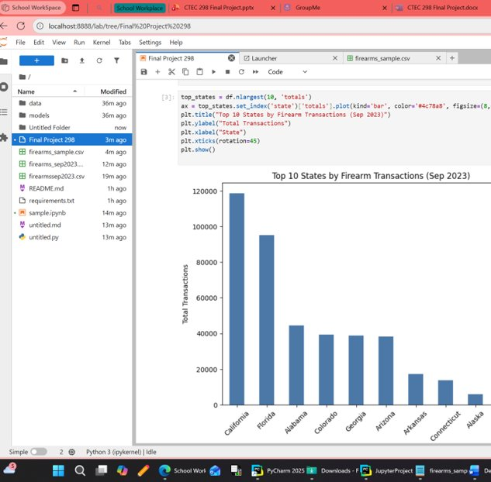
A bar plot was created to show the states with the highest totals. The differences between states were made clear by the bars, with California and Florida appearing much higher than others. The chart was used to highlight how firearm activity was concentrated in certain regions.
Pie chart – Handgun vs Long Gun totals
A pie chart was created to show the overall proportion of handgun and long gun transactions. Handguns were shown to make up most of the activity, while long guns accounted for a smaller share. The chart was used to simplify the nationwide distribution into an easy visual.
Scatter Plot – Hand gun vs Long Gun
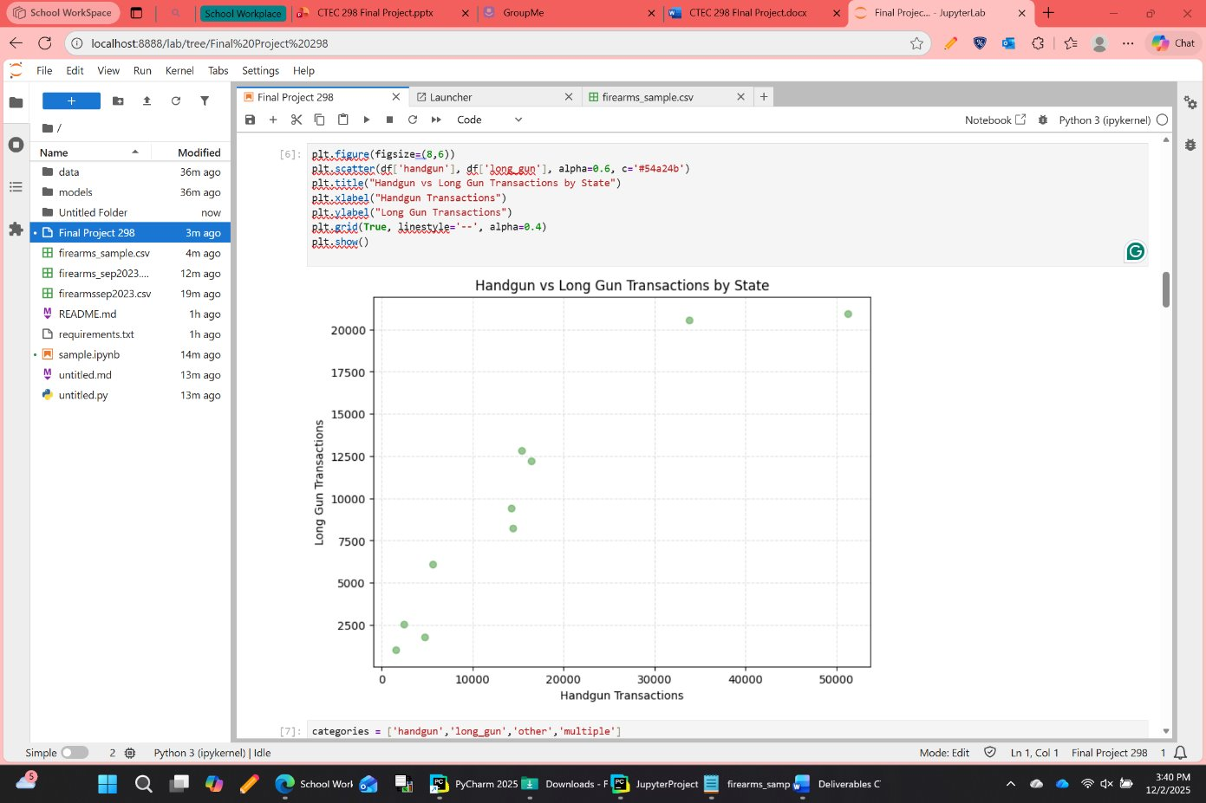
A scatter plot was drawn to compare handgun transactions with long gun transactions. Each state was represented by a point, and the balance between the two categories was made visible. Outliers were noticed, since a few states showed much higher handgun activity compared to long guns.

Histogram – Distribution of totals
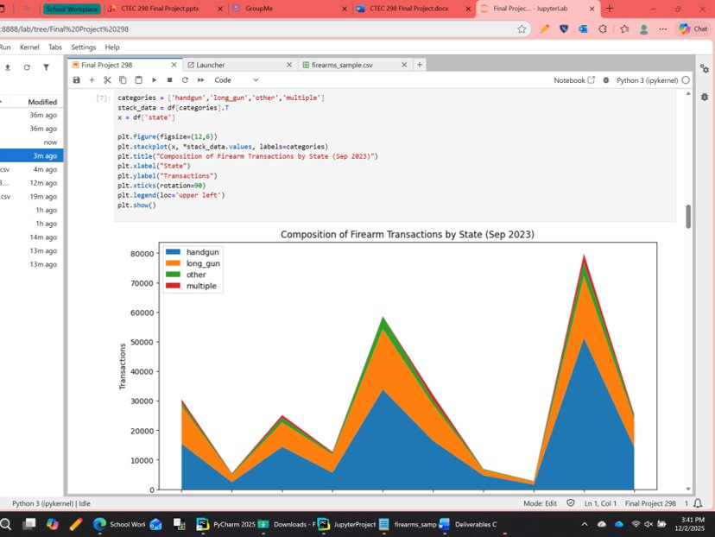
A histogram was used to display how states were spread out by their total transaction counts. Most states were shown to fall in the middle range, while only a few reached very high totals. The chart was helpful for showing that firearm activity was not evenly distributed.

Stack plot – Composition by State
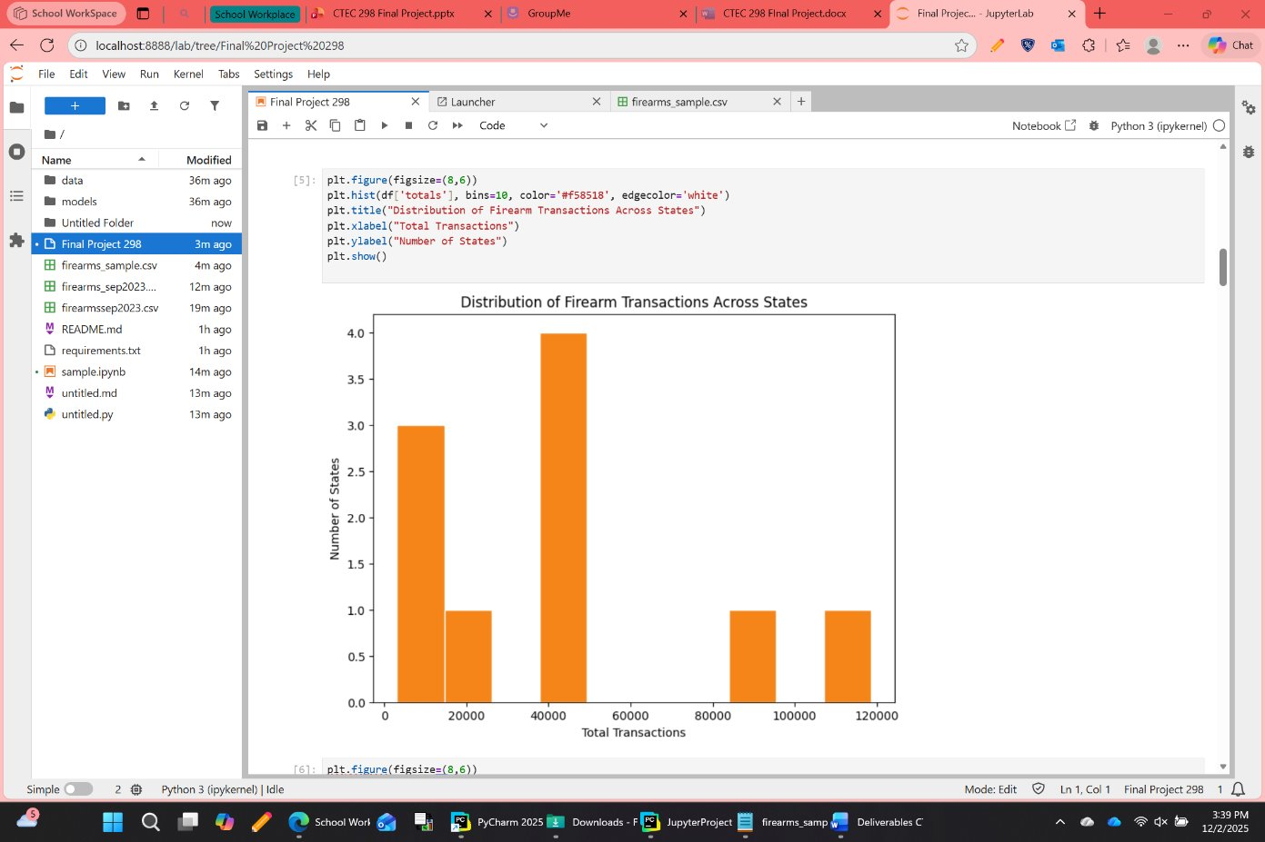
A stack plot was used to display how each category contributed to the totals in different states. Handguns, long guns, other, and multiple purchases were layered together so the mix could be seen. Regional preferences were revealed, since some states were shown to lean more toward one type of firearm than another.

Multi Plot - dashboard view
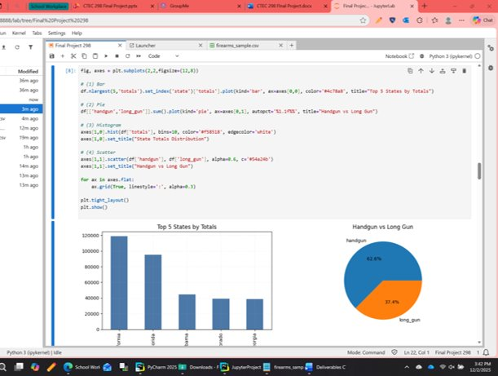
A multiplot was created to combine several graphs into one dashboard. The bar, pie, histogram, and scatter plots were placed together so multiple perspectives could be seen at once. This layout was used as a summary, since it gave both the big picture and the details in one view.

Tableau Plot
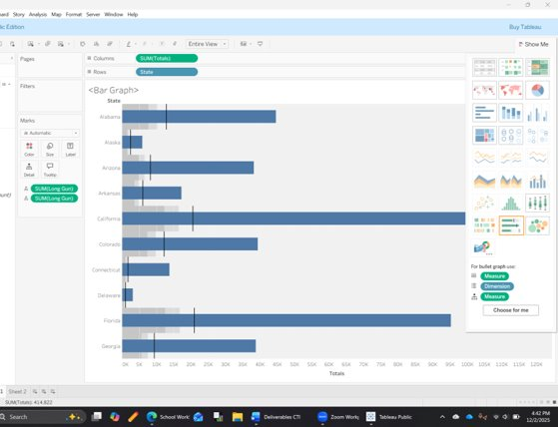

Summary/ Conlusion
Overall this project has taught us how to use Python and visualize our own dataset using a outline. Each member worked on their respective datasets the same techniques was use such the six visualization plots, explaining the dataset, also how to prepare data such as data wrangling. This demonstrated how felxiable Python is when it comes to handling different types of data, especially perfoming taks like cleaning, sorting, calculating, and generating visuals.
Each group member uses each plot visualization such as bar plot, pie chart, bar chart, scatter plot, stack plot, multiplot in different aspecets of our dataset. But even though it was diiferent it still made us undertsand each other data and how it was being analyzed.

References
2023 ACS PUMS DATA DICTIONARY (2024, October 17) UnitedSatesCensus.gov https://www2.census.gov/programs-surveys/acs/tech_docs/pums/data_dict/PUMS

BuzzFeed News. (2023). NICS Firearm Background Checks [Data set]. GitHub. Retrieved from https://raw.githubusercontent.com/BuzzFeedNews/nics-firearm-background-checks/refs/heads/master/data/nics-firearm-background-checks.csv

